Loan Data

Loans by Term

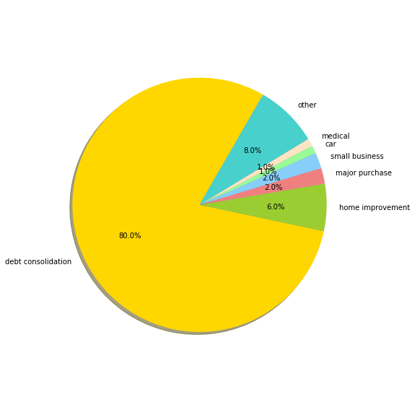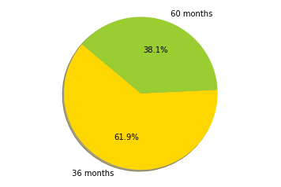

LoansbyPurpose

Loans by Income Group

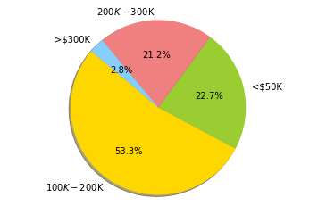

Loans by Home Ownership

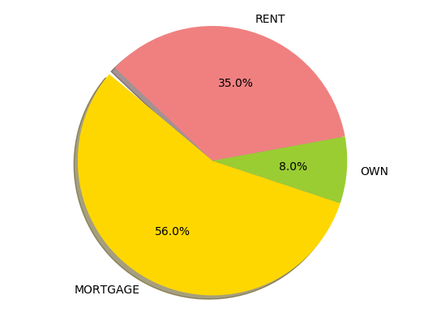

Loans by State

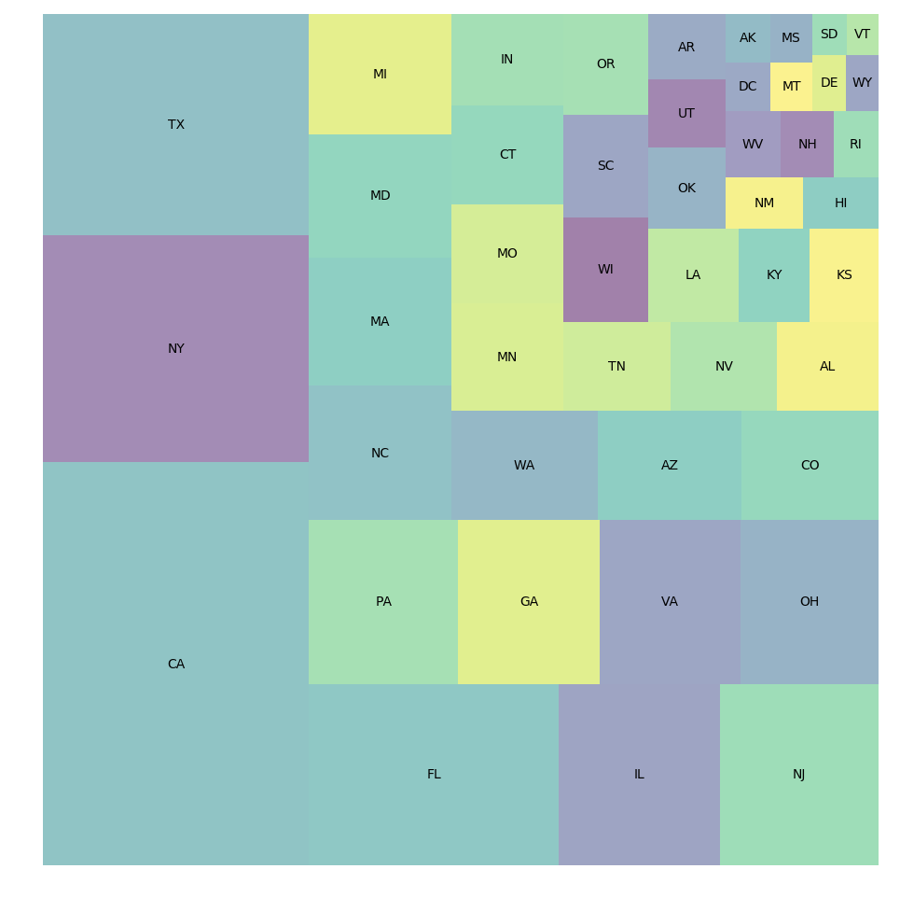

Default Data

Default by Term

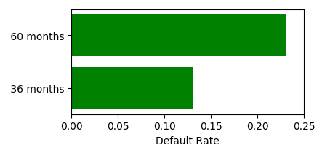

Default by Purpose

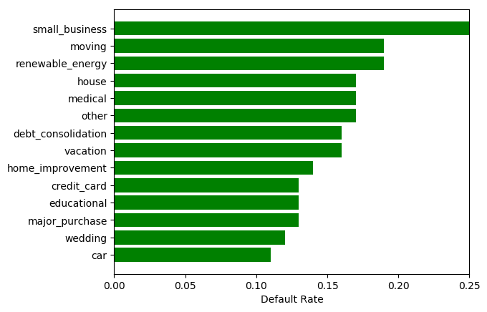

Default by Income Group

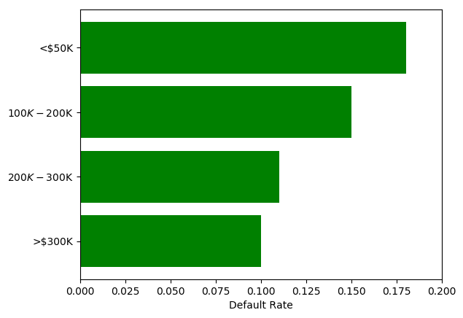

Default by Home Ownership

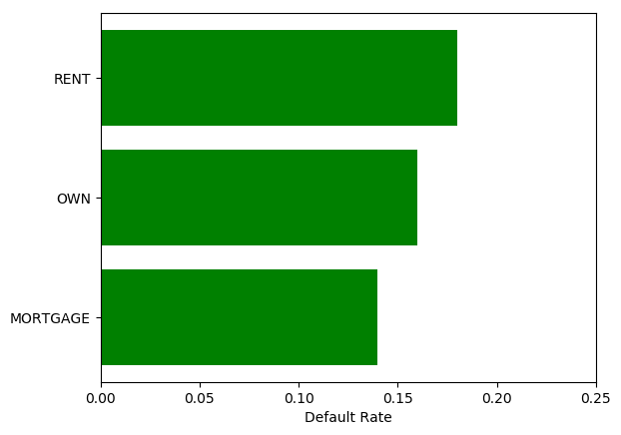

Default by State

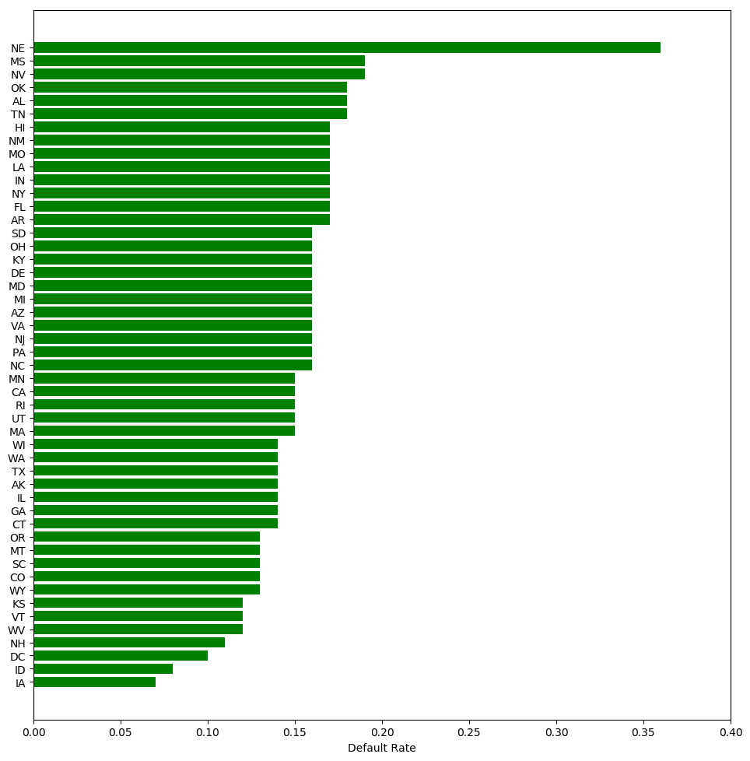

Grade Information

Interest Rate by Grade Loans by Grade

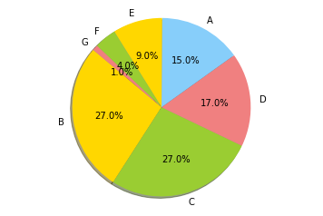

|  |  |
| --- | --- |
| **grade** | **Average  Interest** |
| A | 7.34% |
| B | 10.99% |
| C | 13.41% |
| D | 15.20% |
| E | 16.39% |
| F | 17.72% |
| G | 19.03% |

Default by Grade

